**The Great War (World War I or The First World War) (1914-18)**

The Great War was fought from 1914 to 1918, and was officially ended in 1919 by the Treaty of Versailles. Its primary locus was the trench war on the Western Front between the Entente Powers (the British, French, and Russian empires, the US from 1917, and many other nations) and the Central Powers (the German, Austro-Hungarian, and Ottoman Empires and Bulgaria). By the time the armistice was signed at Compiègne, at 11am on 11 November 1918, almost nine million combatants had been killed. It was the first truly global war, whose modernity was felt in its scale, technology and the corresponding speed with which events could be reported. The impact of the war was unavoidable in Europe, and was felt in literature at the levels of content and form, in modernist prose and poetry, by men and women, combatants and civilians.

**Western Front Timeline**

3 Aug 1914 July-Nov 1916 Mar-Jun 1918 11 Nov 1918

Britain declares Battle of German spring Armistice signed

war on Germany the Somme offensive at Compiègne

| | | | | | |

April-May 1915 July-Nov 1917 Aug 1918

First Battle of Ypres Third Battle British

inc. first use of of Ypres breakthrough

gas by Germans (Passchendaele) at Albert

**Literary Timeline**

1914 1916 1918 1922

H.G. Wells, Wells, *Mr Britling* Rebecca West, *Return* C.E. Montague

*The War That Will Sees It Through*; Rose *of the Soldier*; Arnold *Disenchantment*;

*End War* Macaulay, *Non-* Bennett, *The Pretty Lady*;Ernest Raymond,

*Combatants & Others*; Siegfried Sassoon, *Counter Tell England*; T.S.

Robert Graves, *Over* *Attack & Other Poems*  Eliot, *The Waste Land*

*the Brazier*

| | | | | | |

1915 1917 1920

Rupert Brooke, Siegfried Sassoon,D.H. Lawrence,

*1914 & Other The Old Huntsman*; *Women in Love*;

*Poems* Robert Graves, *Fairies* Wilfred Owen,

a*nd Fusiliers*  *Poems*; Ezra Pound,

*Hugh Selwyn Mauberley*

1924-8 1928 1930 1937

Ford Madox Ford, Erich Maria Remarque, Siegfried Sassoon, David Jones, *In*

*Parade’s End All Quiet on the Western Memoirs of an Infantry Parenthesis*;

tetralogy *Front*; R.C. Sherriff, *Officer*; Frederic Wyndham Lewis,

*Journey’s End* Manning, *Her* *Blasting and*

*Privates We Bombardiering*

| | | | | | |

1925 1929 1933

Virginia Woolf, Richard Aldington, Vera Brittain,

*Mrs Dalloway Death of a Hero*; Robert *Testament of Youth*

Graves, *Goodbye to All*

*That*; Ernest Hemingway,

*A Farewell to Arms*

The assassination on 28 June 1914 of Archduke Franz Ferdinand, the Austro-Hungarian heir presumptive, was the spark which ignited the tinder-dry antagonisms between Austro-Hungary and Serbia; Germany and the Francophone countries (France, Belgium, Luxembourg); and Russia and Germany. The tensions behind the conflict had grown over the previous century, from the end of the Napoleonic wars in 1815, through the Franco-Prussian War of 1870-1, to the series of treaties between the major powers of Europe which were subsequently established. War between Britain and Germany was prophesied in late nineteenth- and early twentieth-century invasion literature such as Erskine Childers’ *The Riddle of the Sands* (1903) and William Le Queux’s (1864-1927) popular *The Invasion of 1910* (1906); E.M. FORSTER (1879-1970) alludes to the possibility in *Howards End* (1910). However, these tensions were set around the defining narrative that civilisation connoted progress, and that the human race was perfectible. Even writers who explored social discontent and class conflict retained that belief. Joseph CONRAD (1857-1924) was a notable exception, and *Heart of Darkness* (1901) despairs at Western values. Civilisation and barbarism are opposite sides of the same coin; scratch at the surface of Western imperialism, says Conrad, and the façade will quickly crumble. The counter-realism of German Expressionism, founded in 1910, was drawn to the commodification, cruelty and alienation of human experience. Alongside the narrative of progress there was a developing expression of discontent both with and in modernity, and this language was mobilised in the response to the war.

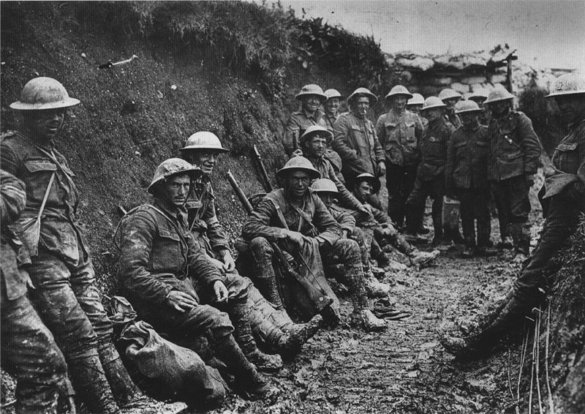The onset of war was initially greeted with enthusiasm by groups of patriots on both sides, and by some intellectuals who believed that war would purify a decadent society. The founder of futurism, F. T. Marinetti (1876-1944), glorified war in his 1909 manifesto as ‘the world’s only hygiene’, and many futurists later volunteered. Marinetti claimed that thirteen died, including Umberto Boccioni (1882-1916), his manifesto collaborator and the movement’s main theorist. Whilst fighting in the French army, the Vorticist sculptor and painter Henri Gaudier-Brzeska (1891-1915) asserted from the trenches, shortly before he was killed, that ‘This war is a great remedy’ (<http://bit.ly/Mxl4py>).

Enthusiasm was not all-encompassing, however: dissent was registered in public and private, by individuals and organizations, in speeches and in print. The Bloomsbury group espoused philosophical pacifism as a basic ethical principle. Lytton Strachey (1880-1932), the critic, biographer and unofficial spokesman for Bloomsbury, asked to be treated as a conscientious objector, and Forster declared himself a pacifist. The art critic Clive Bell (1881-1964) also drew opprobrium by his polemical *Peace at Once* (1915), in which he argued for a negotiated settlement to the war; it was banned in 1916. Other tensions were seen in the role of Commonwealth forces. Indian and Irish separatists sought to capitalise on the role of their troops in the war effort in the drive towards increased autonomy, and Irish republicans famously initiated the Easter Rising of 1916.

There was a brief initial phase of movement in the war, but by the end of 1914 the trench system was well-established, stretching for hundreds of miles through France. The Western Front has become synonymous with the experience of the Great War and the majority of the military force was focused there, although campaigns were also fought in Africa, Asia, the Balkans, and the Middle East. The first day of the Battle of the Somme, 1 July 1916, saw some of the bloodiest fighting in modern history. The antagonists struggled to deploy the developing tools of mechanised warfare on the ground (tanks), under the sea (U-boats) and in the air (zeppelins, fighter aircraft, strategic bombers and, later, aircraft carriers). It was not until 1918, as the war threatened to stretch into the subsequent decade, that movement returned: the Central Powers appeared to take the upper hand early in the year, before the Entente Powers broke through decisively in August and then October.

**Modernist Deaths in the Great War**

1914 1916 1918

Alfred Lichtenstein, Alan Seeger, Isaac Rosenberg,

Charles Péguy Umberto Boccioni Wilfred Owen,

Guillaume Apollinaire

| | | | |

1915 1917

Rupert Brooke, T.E. Hulme,

Charles Hamilton Sorley, John McCrae,

Henri Gaudier-Brzeska Edward Thomas

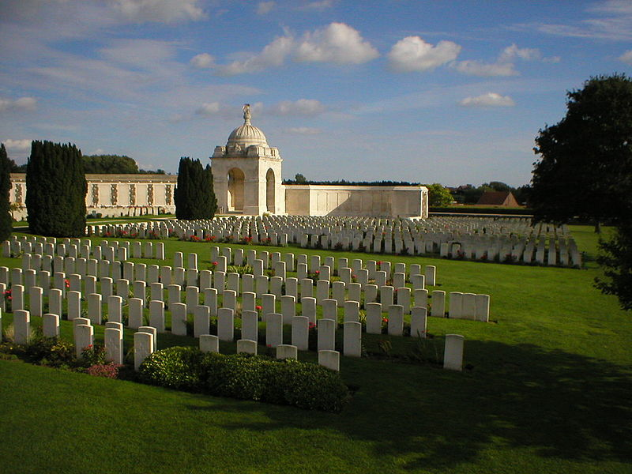

Authors responded to the war from its beginning in a variety of forms and moods. Non-combatant authors were able to write extensively about the conflict earlier than those who chose or were compelled to fight. H.G. WELLS’s (1866-1946) pamphlet *The War That Will End War* (1914) became an enduring phrase, and the failure to achieve a lasting and satisfactory peace contributed to subsequent disillusionment. His *Mr Britling Sees It Through* (1916) is a nuanced depiction of the beginning of the war, which shows the complex and finely-balanced equilibrium of the pre-war world, and the ongoing debates of those years. It was a bestseller in the US and the UK; other popular novels such as John Buchan’s (1875-1940) *Greenmantle* (1916) and Arnold BENNETT’s (1867-1931) *The Pretty Lady* (1918) offer a more subtle take on the conflict than is often credited. Authors who remained outside official structures were more able to speak against the war. Married to a German, D.H. LAWRENCE (1885-1930) was subject to intense scrutiny, and wrote as early as 1915 about the flawed country for which the war was being fought in ‘England, My England’; Rose MACAULAY’s (1881-1958) *Non-Combatants and Others* (1916) deals with pacifism in Britain, and Rebecca WEST’s (1892-1983) *The Return of the Soldier* (1918) is an early novel to deal with the fear of and problems endured by returning combatants.

The war was not an ellipsis in modernism: even those who served continued to write prose and poetry for volume publication and for literary journals. Richard ALDINGTON (1892-1962) remained editor of the *Egoist* until 1918, sharing duties with H.D. (1886-1961) after his 1916 departure for the Western Front; Ford Madox FORD (1873-1939) continued to write throughout his service in Britain and France. T. E. Hulme (1883-1917) believed that war was necessary and volunteered; he composed a ‘Diary from the Trenches’ during his first tour of duty in France. It is a stark, unforgiving account of trench warfare, describing days of profound, anxiety-ridden boredom punctuated by hours of mind-wrenching terror. In one of the ‘War Notes’ he produced for *The New Age* (vol 18 [1-18] http://bit.ly/fHg7Dn), he excoriated Clive Bell for his pacifism and cowardice. In contrast to many of the above, Wyndham Lewis (1882-1957) survived the war relatively unscathed. He was posted to the Western Front in 1917, and during his time there wrote several acerbic war stories, including the notorious ‘Cantleman’s Spring Mate’ (1917; *The Little Review* 4 (6) http://bit.ly/MXZVaJ), censored by the U. S. postmaster for ‘obscenity’. Lewis was also an official war artist for both the British and Canadian governments from December 1917. Lewis’s *Tarr* (1918) and LAWRENCE’s *Women in Love* (1920) do not focus on the war, but deal with passionately-felt, violent interactions between English and German protagonists. Outside the usual purview of high modernism, Robert Graves (1895-1985) and Siegfried SASSOON (1886-1967) published collections of poetry between 1916 and 1918. Along with Wilfred Owen (1893-1918), who was largely unknown until the 1930 republication of his *Poems*, they questioned the way the war was conducted, politically and strategically, but continued to believe that the war needed to be won.

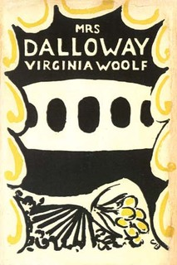Post-war modernist writing often fragments language and narrative. In poetry, Ezra Pound’s (1885-1972) reflections on the war in *Hugh Selwyn Mauberley* (1920) are as vehement as any combatant, in his plea for ‘frankness as never before / disillusions as never told in the old days’; T. S. ELIOT’s (1888-1965) *The Waste Land* (1922) has in mind a wider context of decay and degeneration. The ellipses used by FORD and Virginia WOOLF (1882-1941) highlight a concern with mental processes which finds a new focus in shell shock. Shifts of time and space signal the difficult relationship between the Western Front and the home front and changes in ways of understanding the physical world. WOOLF’s novels of the nineteen twenties address the impact of the war on individual lives and social structures; *Jacob’s Room* (1922), *Mrs Dalloway* (1925) and *To the Lighthouse* (1927) might be considered a trilogy of war novels. *Mrs Dalloway* offers the most overt comment, and the novel’s title character is ‘mirrored’ in oblique ways by Septimus Warren Smith, a shell-shocked World War I veteran. Woolf judiciously shows the symptoms of shell shock to have much in common with modernist narrative poetics: both involve discontinuities of memory, sudden and uncontrollable flashbacks, psychic disjunction, emotional insomnia, and the breakdown of language and identity. These were elite discourses, however, and the popular novel largely remained loyal to traditional forms: Gilbert Frankau’s (1884-1952) *Peter Jackson, Cigar Merchant* (1919) reasserts the value of vigorous capitalism and patriarchal heteronormativity, and the bestselling novel of the nineteen twenties in the UK was Ernest Raymond’s (1888-1974) *Tell England* (1922), a *bildungsroman* about Christian heroism and endurance.

Combatant authors generally took longer to write about war. A common complaint was that the fragmentary nature of war made it resistant to conventional narrative history, and it was repeated often enough that it became a war narrative in itself. This lent a certain prestige to subjective construals of the event, to which the modernist memoir added formal innovation. Ernst Jünger’s (1895-1998) *In Stahlgewittern* (*Storm of Steel*) (1920) was an early and controversial account. Its controversy stems from the morbid pleasure Jünger appears to take in the exigencies of war, manifested in apocalyptic and overwrought rhetoric. He presents combat as a test, a redemptive and regenerative experience that can foster a more authentic personal identity. In England, C.E. Montague was able to criticize the war strongly in *Disenchantment* (1922), an early move away from the heroic mode. Ford Madox FORD’s *Parade’s End* tetralogy (1924-8) defines the early combatant response to the war; using modernist techniques Ford sees the conflict in the light of the uncertain Edwardian world and the difficulties of post-war readjustment. Using a similar family saga form, R.H. Mottram’s *The Spanish Farm Trilogy* is a middlebrow classic, combining Victorian form with modernist metaphor.

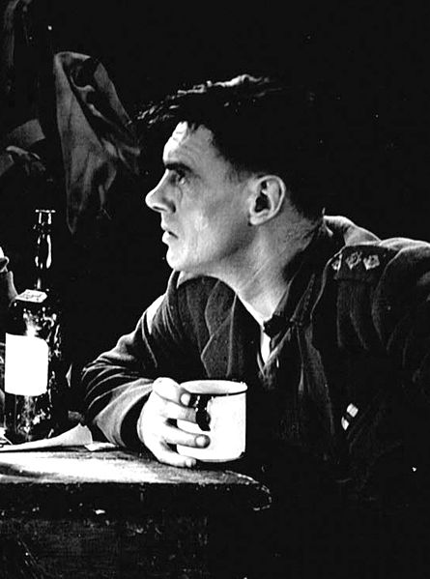The ‘War Books Boom’ of 1928-30 saw an outpouring of war literature which criticized the conduct of military and political hierarchies. Influential in stimulating this were Erich Maria REMARQUE’s (1898-1970) *Im Westen Nichts Neues* (*All Quiet on the Western Front*) (1929), first serialized on the tenth anniversary of the armistice and soon a bestseller in translation across Europe, and R.C. Sherriff’s (1896-1975) play *Journey’s End* (1928). Richard ALDINGTON’s *Death of a Hero* (1929) and Ernest HEMINGWAY’s (1899-1961) *A Farewell to Arms* (1929) were early novels to capitalize on the interest generated, and were quickly followed by works such as Robert GRAVES’s *Goodbye to All That* (1929) and Siegfried SASSOON’s *Memoirs of an Infantry Officer* (1930), the second of his Sherston trilogy; Frederic Manning’s (1882-1935) *The Middle Parts of Fortune* (1930) draws on *Journey’s End* for its structure and recasts it in the style of a service record.

The films of the two successes which precipitated the boom contributed to its decline in the latter part of 1930. The focus was already on looking towards a new war, although notable responses to the Great War continued to appear, such as Vera BRITTAIN’s (1893-1970) *Testament of Youth* (1933) and David JONES’s (1895-1974) *In Parenthesis* (1937), a prose-poem as much mythological reclamation as it is memoir. Jones was an infantryman for the Royal Welch Fusiliers; like Jünger, he took part in the First Battle of the Somme in 1916, which provides the basis for his work’s climactic episode. *In Parenthesis* is composed throughout of voices, most of them unbidden and unidentified, articulating half-forgotten songs, soldiers’ chants and church hymns, and promoting allusions to Celtic myth and Arthurian legend. Almost twenty years in the making, Jones’s poetic reconstruction of soldierly life conjoins intimacy and anonymity, camaraderie and estrangement. On the eve of another global cataclysm, it was a fitting epitaph for the modernist war experience.

**Histories of the Great War**

Gregory, Adrian (2008). *The Last Great War: British Society and the First World War*. Cambridge: Cambridge University Press.

Kennedy, David M. (2004 [1980]). *Over Here: The First World War and American Society*. New York: Oxford University Press.

Holmes, Richard (2005). *Tommy: The British Soldier on the Western Front, 1914-1918*. London: Harper Perennial.

Strachan, Hew (2003). *The First World War: A New Illustrated History*. London: Simon & Schuster.

Todman, Dan (2005). *The Great War: Myth and Memory*. London: Continuum.

**Selected Literary and Cultural Criticism about the Great War**

Atkin, J. (2002). *A War of Individuals: Bloomsbury Attitudes to the Great War*, Manchester: Manchester University Press.

Bond, Brian (2002). *The Unquiet Western Front: Britain’s Role in Literature and History*. Cambridge: Cambridge University Press.

Carden-Coyne, Ana (2009). *Reconstructing the Body: Classicism, Modernism, and the First World War*, Oxford and New York: Oxford University Press.

Cobley, Evelyn (1993). *Representing War: Form and Ideology in First World War Narratives*. Toronto: University of Toronto Press.

Cole, Sarah (2003). *Modernism, Male Friendship and the First World War*. Cambridge: Cambridge University Press.

Eksteins, Modris (2000 [1989]). *Rites of Spring: The Great War and the Birth of the Modern Age*. Boston, New York: Houghton Mifflin.

Hewitt, Andrew (1993) *Fascist Modernism: Aesthetics, Politics, and the Avant-Garde*, Stanford: Stanford University Press.

Hynes, Samuel (1990). *A War Imagined: The First World War and English Culture* (New York: Collier Books / Macmillan.

Sherry, Vincent (2003). *The Great War and the Language of Modernism*. Oxford: Oxford University Press.

Sherry, Vincent (ed.) (2005). *The Cambridge Companion to the Literature of the First World War*. Cambridge: Cambridge University Press.

Smith, Angela K. (2000). *The Second Battlefield: Women, Modernism and the First World War*. Manchester: Manchester University Press.

Tate, Trudi (1998). *Modernism, History and the First World War*. Manchester: Manchester University Press.

Walsh, Michael J. K. (ed.) (2010). *London, Modernism, and 1914*, Cambridge: Cambridge University Press.

Winter, Jay M. (1995). *Sites of Memory, Sites of Mourning: the Great War in European Cultural History*. Cambridge: Cambridge University Press.

**Paratextual Material**

(1) Lewis, W. (ed) (1914) *Blast* 1 <<http://bit.ly/OAfirj>> The Modernist Journals Project (searchable database). Brown and Tulsa Universities, ongoing. (See <http://bit.ly/p4o7vl> for copyright, permissions information.)

(2) German Expressionism (“particularly sex, i.e., prostitution”): [**attached**]

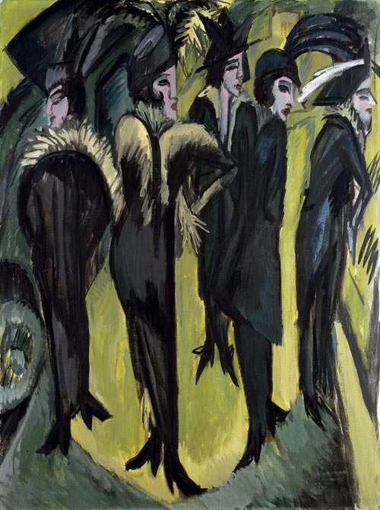

**Fig. 1** Kirchner, E. L. (1913) *Five Women on the Street*, Museum Ludwig <<http://bit.ly/Qu2hl5>>.

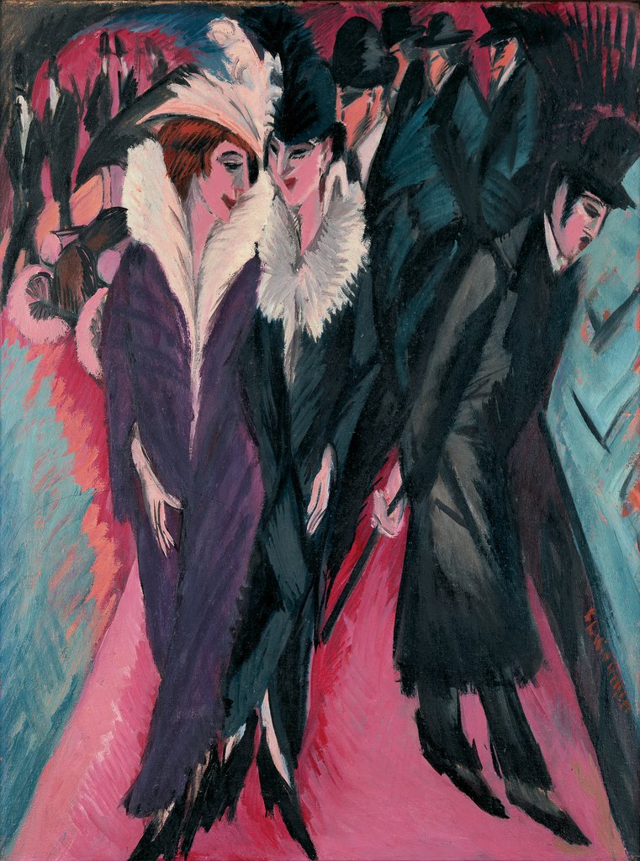

**Fig. 2** Kirchner, E. L. (1913) *Street, Berlin*, Museum of Modern Art <<http://bit.ly/penxrl>>.

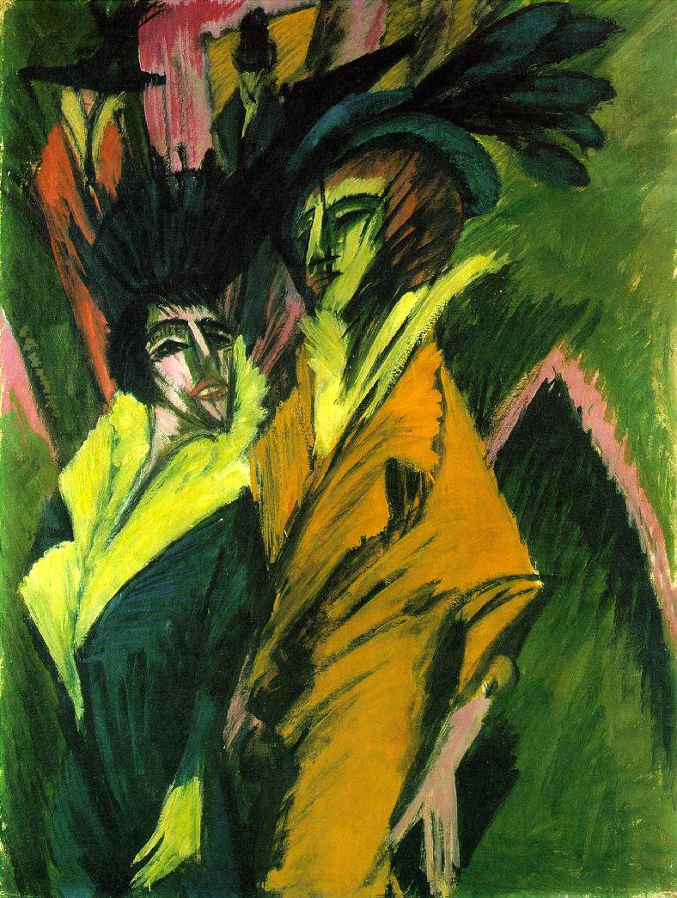

**Fig. 3** Kirchner, E. L. (1914) *Two Women in the Street*, Kunstsammlung Nordrhein-Westfale *<*http://bit.ly/MhMYKG*>*.

(3) Henri Gaudier-Brzeska (Vorticist sculptor and painter): [**attached**]

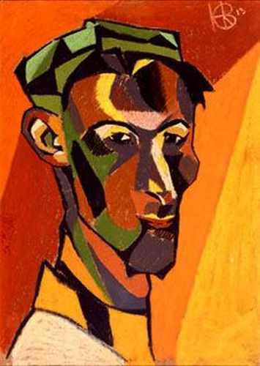

**Fig. 4** Gaudier-Brzeska, H. (1913) *Self Portrait*, Southampton City Art Gallery <http://bit.ly/Pnx8c8>.

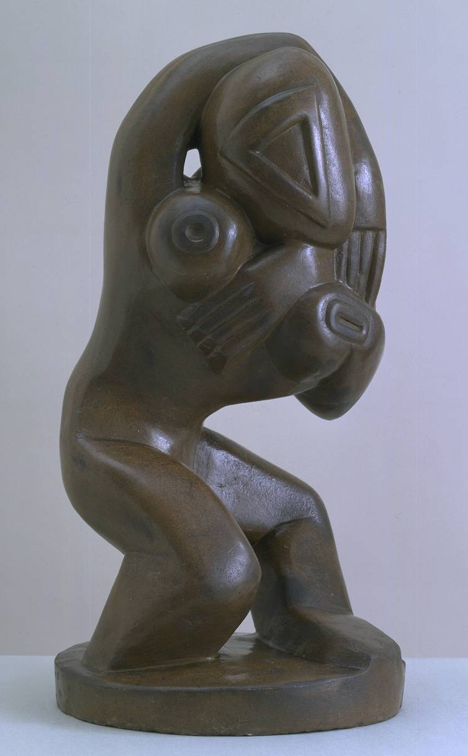

**Fig. 5** Gaudier-Brzeska, H. (1913) *Red Stone Dancer*, Tate Britain <http://bit.ly/N9rF90>.

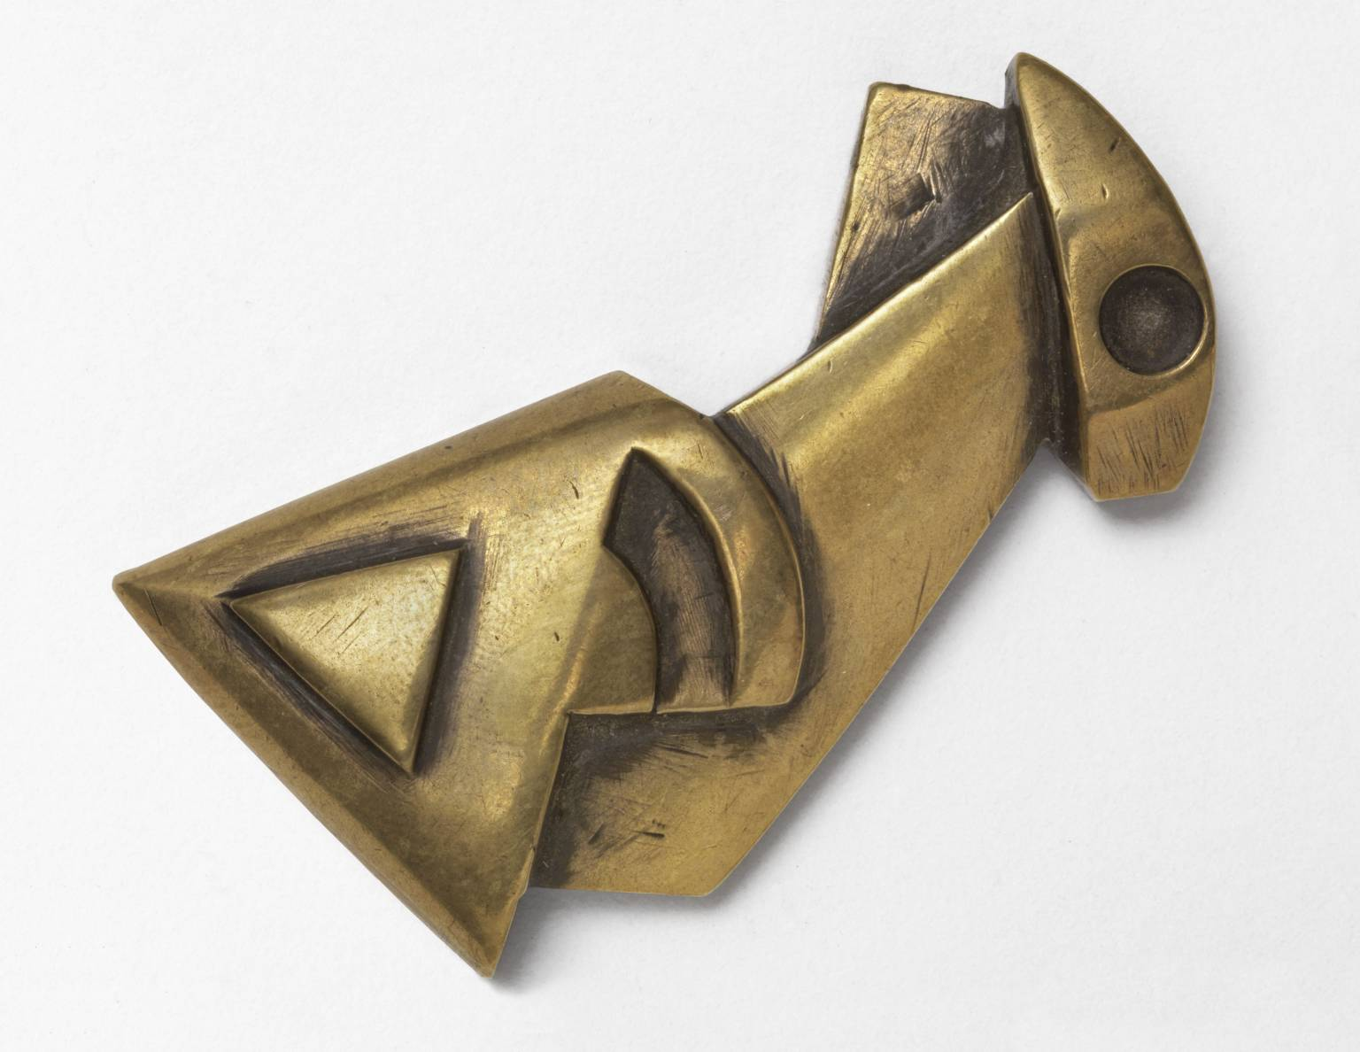

**Fig. 6** Gaudier-Brzeska, H. (1914) *Fish*, Tate Britain, <http://bit.ly/Qu551w>.

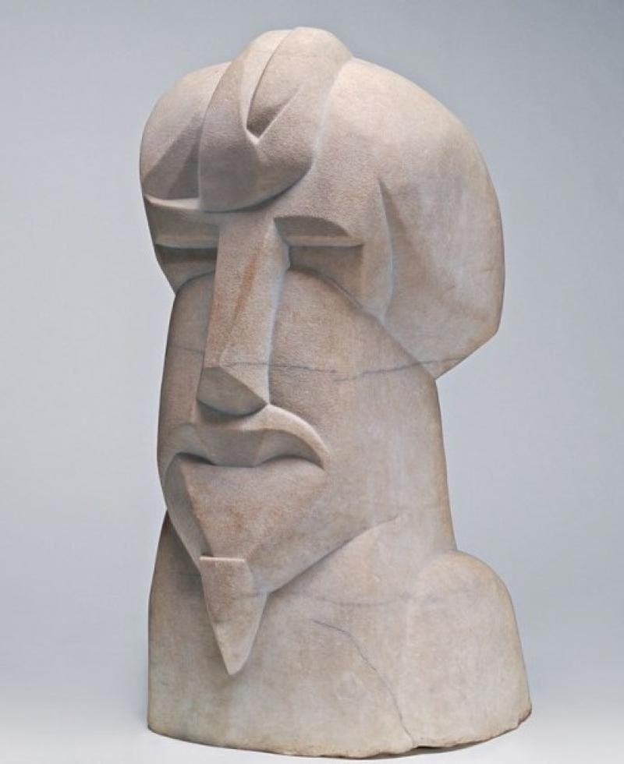

**Fig. 7** Gaudier-Brzeska, H. (1914) *Hieratic Head of Ezra Pound*, National Gallery of Art, Washington <http://bit.ly/R5Anen>.

(4) Wyndham Lewis (war art): **[attached**]

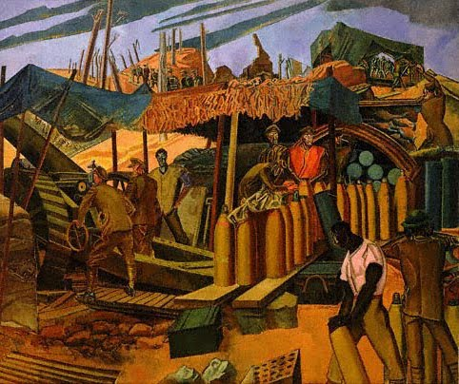

**Fig. 8** Lewis, W. (1918) *A Canadian Gun-pit*, National Gallery of Canada <http://bit.ly/NHLwBd>.

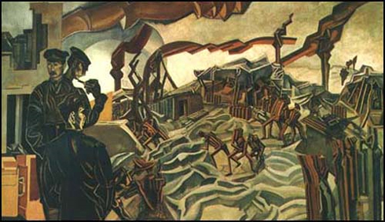

**Fig. 9** Lewis, W. (1919) *A Battery Shelled*, Imperial War Museum < http://bit.ly/IxjnG8>.

Suggested Images:

1. To replace existing trench photo: <http://dianaoverbey.files.wordpress.com/2012/01/allied-forces-diggin-trenches.jpg> (entrenching, higher resolution than original inclusion)

2. To replace existing war memorial photo: I have a number of photos, appositely, of the Vimy Ridge (Canadian) memorial. I’ve attached what I think is the best to this e-mail, and have other part-shots and abstracts (what I think is a good one detail of one name looking across to many others). I also have some of the Arras memorial (rows of white stones style, have a good pic which shows different demoninations). Let me know what you think.

3. Mrs. Dalloway cover. Online low resolution source at <http://en.wikipedia.org/wiki/File:Mrs._Dalloway_cover.jpg> ; picture of jacket including spine at <http://modernism.research.yale.edu/wiki/index.php/File:Mrs_Dalloway.jpg> . A higher resolution scan of this would be ideal, but I don’t have access to that jacket.

4. Colin Clive as Stanhope in *Journey’s End* (1930 film). From <http://en.wikipedia.org/wiki/File:Colinclive.jpg> ; source picture <http://commons.wikimedia.org/wiki/File:BIlly_Bevan_(4).jpg> . Photo is incorrectly dated source picture page – must be 1930 film (first performance of play not until Dec 1928).